**NXP AIM India Online Design Challenge**

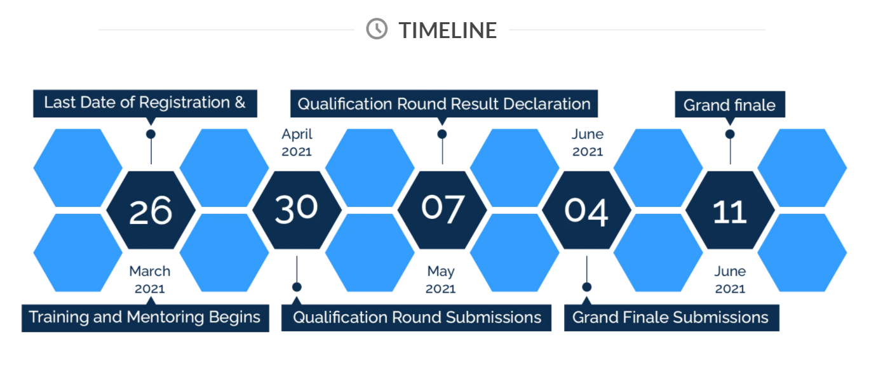

**OBJECTIVE**

**The objective of this online challenge is to design and develop the CAR models as per the guidelines, develop algorithms using AI/ML**

**to handle obstacles on the track provided by NXP AIM INDIA.**

**DESIGN AND DEVELOP**

* **Car Model with defined specifications**
* **Software Algorithms**
* **Sign recognition Software**
* **System Integration**

**PROCESS**

* **Registration**
* Register and enrol in the challenge
* **Installation**

**-** Ubuntu

- GaZebo

**-** ROS

- PX4

**-** rQT Image Viewer

(“Installation guide to be provided post registration”)

* **Model Creation** - Design, Develop and Integrate components of the car model with defined specifications.
* **Training & Webinars**
* Meet, interact and learn from leading industry experts. Get your questions answered.

* **Testing**
* Integrate NXP AIM INDIA Sample track & test your car model
* **Submission & Judging**
* Submit code, Documents and all deliverables for judging